Screen prints from CDC ndc crosswalk
https://www2a.cdc.gov/vaccines/iis/iisstandards/vaccines.asp?rpt=ndc
ActHIB

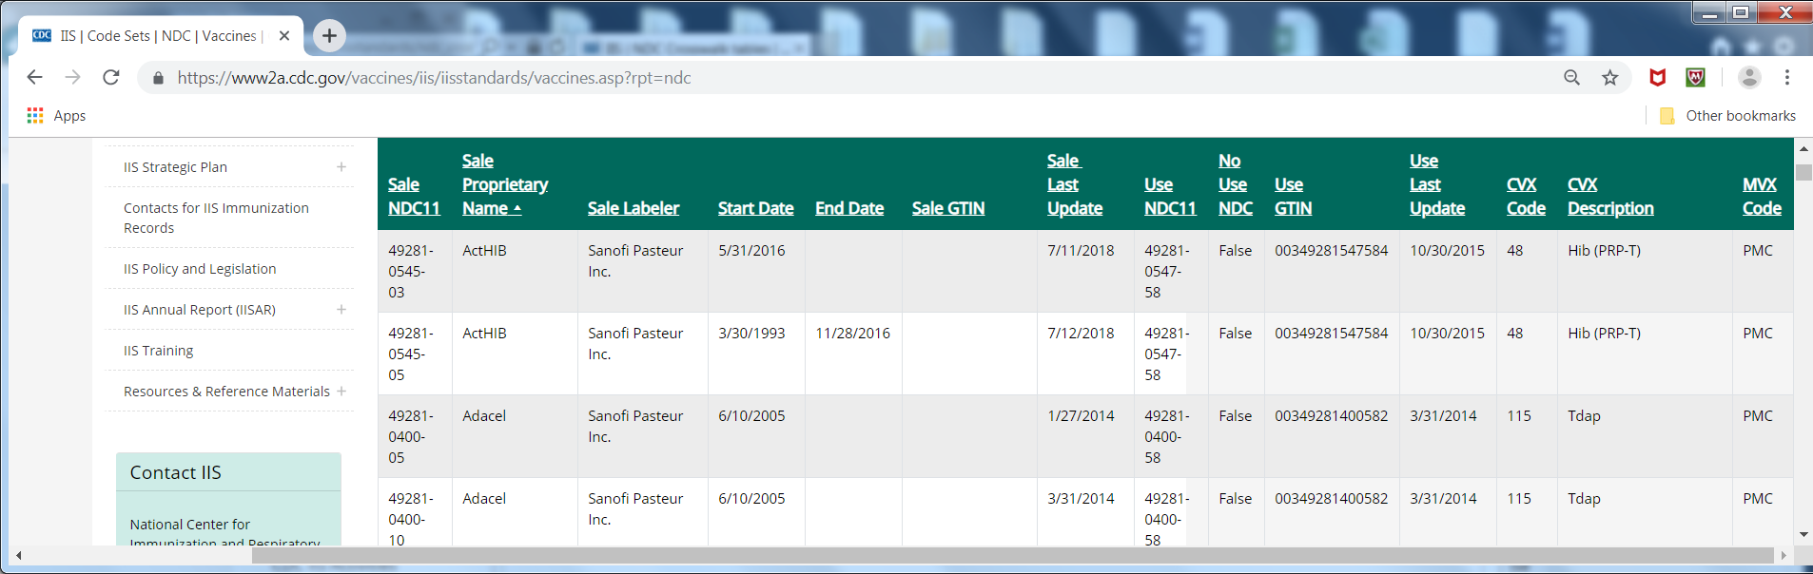

Pentacel

