An oncology extension to the OMOP CDM has been proposed for cancer related information and treatment. To a cancer patient, diagnosis and treatment are certainly important. Reporting Adverse Drug Reaction (ADR) is also an important part of patient care.
Since there is no suggestion on the side effect of the administered medications on the patient after receiving the diagnosis and treatment, we would like to make a proposal.

Generally, ADR uses standardized classification code called CTCAE (Common Terminology Criteria For Adverse Effects). It was to grade the severity of ADR by the US NCI (US National Cancer Instituted). CTCAE divides ADR into 5 grades. Table.1 shows the side effect of the post-treatment on Anorexia from Grade 1 to 5. Each Grade is defined by its level of severity.(Table.2)
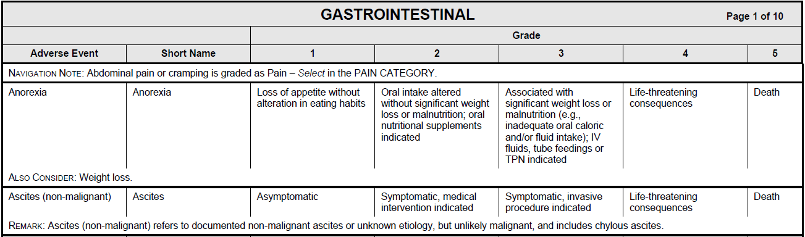
[Table.1] CTCAE(Common Terminology Criteria for Adverse Effects)

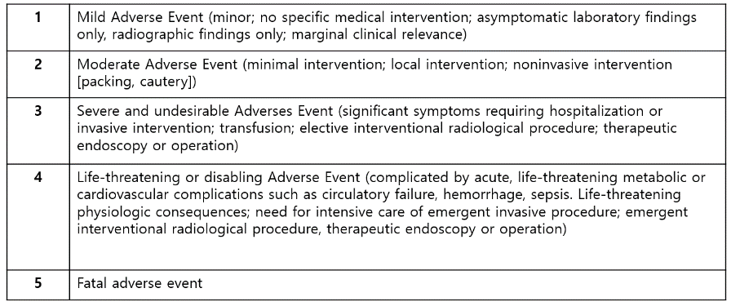
[Table. 2] Definition of each Grade in CTCAE

The most recent version of CTCAE is version 5.0, and Samsung Medical Center (SMC) uses CTCAE version 3.0. [Fig. 1] patients in SMC are put into Grade 0 to Grade 4. Grade 0 being the norm, and Grade 5 is not in use since it represents an expired patient.
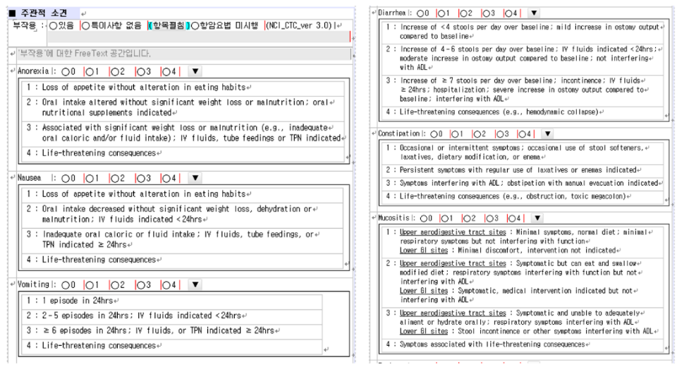
[Fig. 1] EMR chart for reporting ADR in Samsung Medical Center

CTCAE is the standardized classification system for ADR. However, unlike other international standard codes including SNOMED-CT, ICD-10, UMLS, LOINC etc., CTCAE does not possess its own characteristic codes. The reason is that CTCAE uses low-grade terms from MedDRA codes.
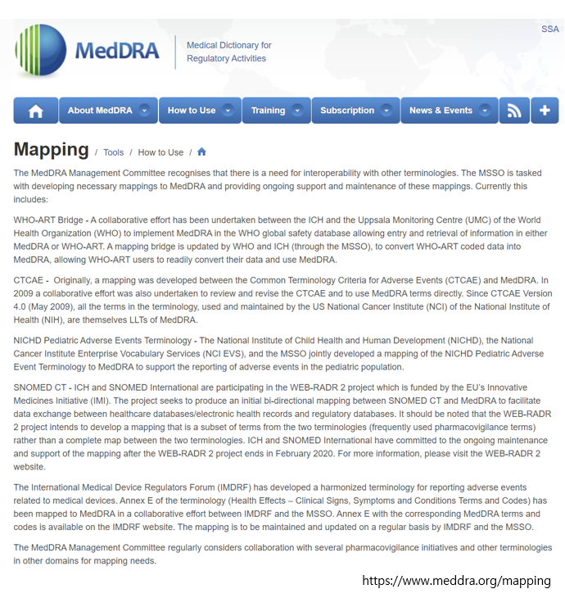
[Fig.2] Mapping between CTCAE and MedDRA codes
MedDRA is a medical dictionary made by the ICH (International Council for Harmonization of Technical Requirements for Pharmaceuticals for Human Use), designed to facilitate the pharmaceutical regulations internationally.(Fig.3)
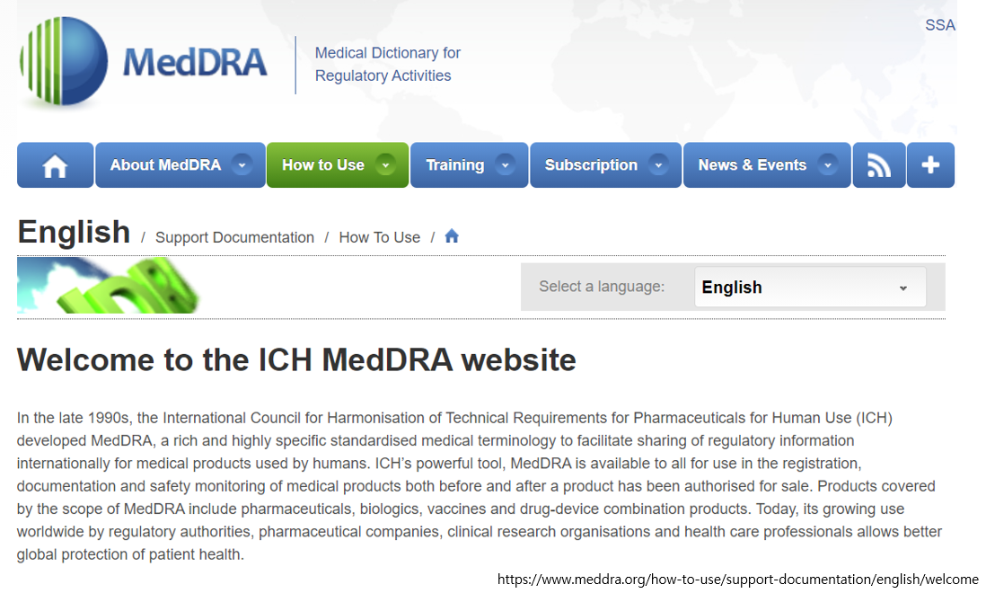
[Fig.3] MedDRA의 정의
In other words, CTCAE and MedDRA are each defined differently, but CTCAE uses the low-grade terms from MedDRA. Since CTCAE only uses the terms from MedDRA, it gets mapped as OMOP Concept ID. Therefore, all Grades contained in CTCAE get omitted. (Fig.4)
Grade is crucial for patient care and treatment that can show the severity of ADR, thus without the proper data of Grade it can lead to malpractice or insufficient CDM data research.

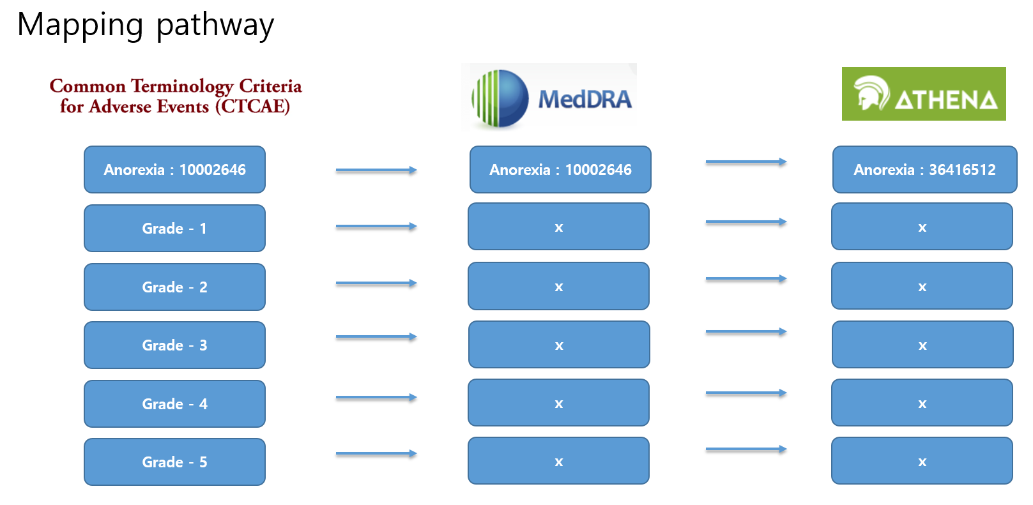
[Fig.4] Process of grade being omitted in CTCAE on mapping to MedDRA

Another problem is that MedDra is simply a medical dictionary that standardizes the pharmaceutical information. On the other hand, CTCAE is concepts that are made after direct observations by the physician or from the patient’s feedback.
Generally, terms like anorexia, vomiting, or rhinitis can be considered as a condition, but the domain can be changed by the usage. A condition is typically an ailment diagnosed by a doctor. On the other hand, CTCAE is the assessment after observing the side effect by a medical staff, or the assessment of patient’s response. CTCAE cannot be seen as a condition in this aspect. CTCAE should be regarded as a finding or a situation rather.
Therefore, questions for CTCAE can be applied as concepts in observation domain, and the answer, Grade, is the qualifier value. Currently, around 100,000 MedDRA codes exist, and 780 MedDRA codes are being used in CTCAE version 5.0. Out of these, about 95% are included as condition, 4% as measurement and observation, 1% as procedure, and 0% as OMOP in the domain. (Fig 5)

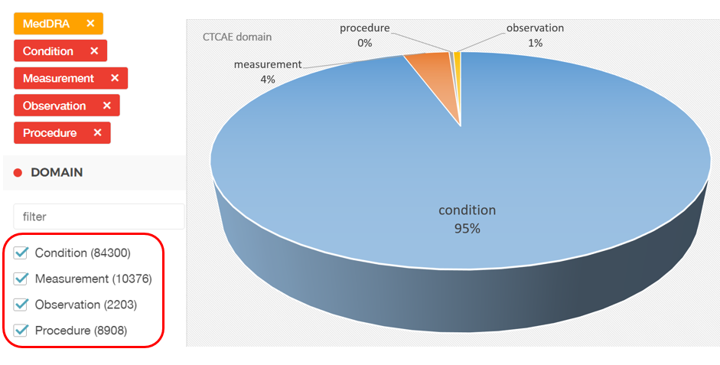
[Fig. 5] CTCAE OMOP domain

Codes included in the domain such as condition or procedure cannot be defined cannot save the qualifier value. Thus, information loss is inevitable.
Because of problems stated above, we would like to make a new proposal on ADR.
First, to prevent information loss on CTCAE, you should avoid using MedDRA terms. You’d better use CTCAE based OMOP vocabulary instead. Second the Grade from 1 to 5 should be included in qualifier values.
. (Fig.6) .

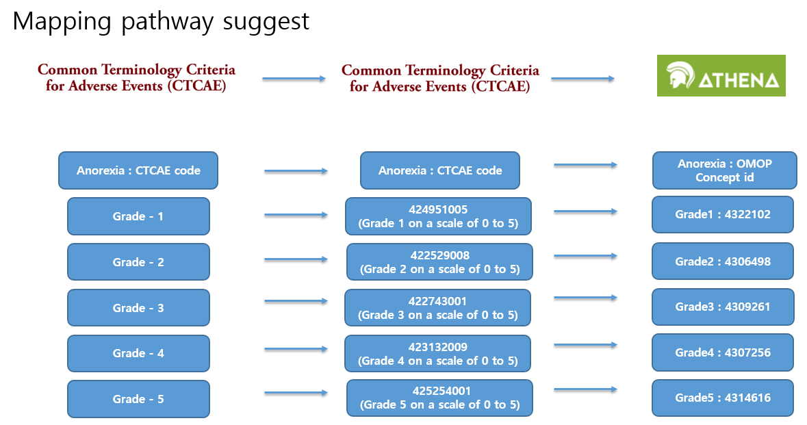
[Fig 6] CTCAE Mapping pathway suggest
Mapping pathway suggestion

